ACADIA 2017
SPONSORSHIP PROSPECTUS

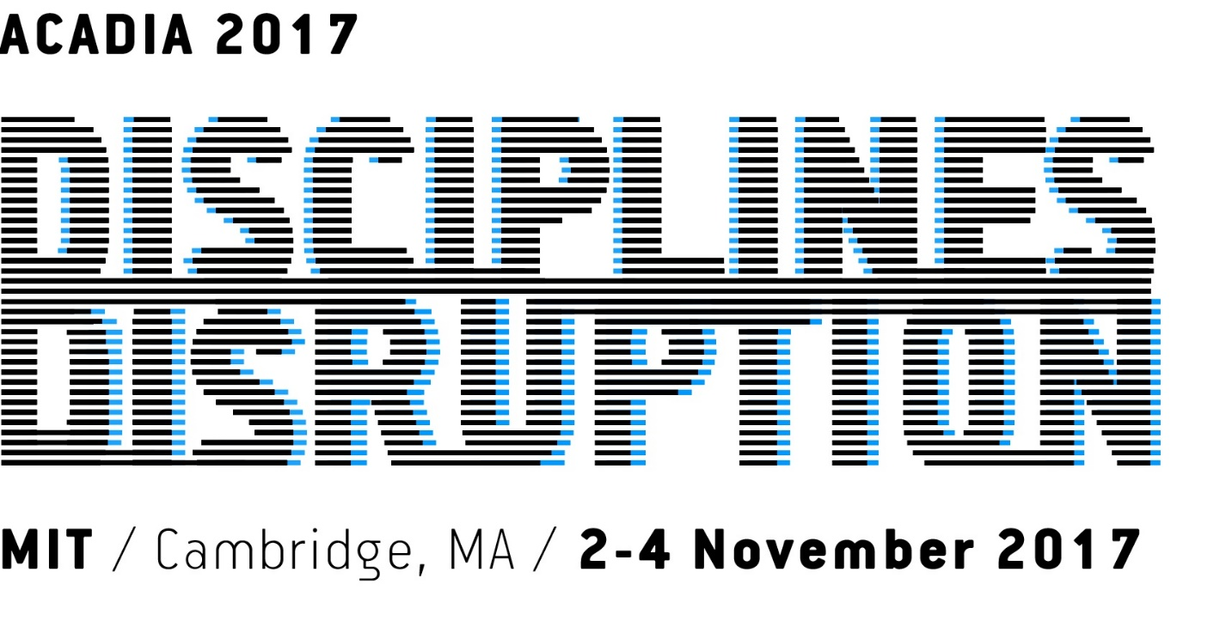

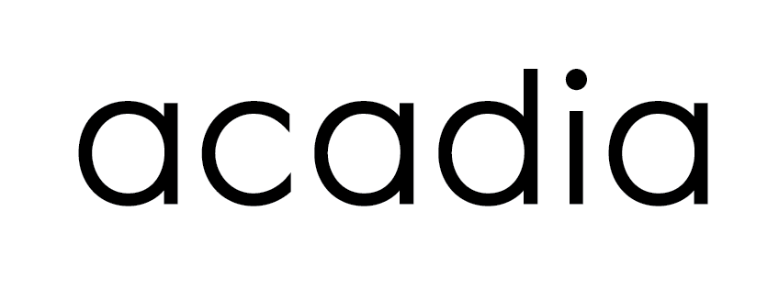
Please direct all sponsorship inquiries to Shane Burger
email: development@acadia.org

For 2017 conference details visit: http://2017.acadia.org

ACADIA 2017

THEME

Disciplines & Disruption initiates a dialog about the state of the discipline of architecture and the impact of technology in shaping or disrupting design, methods and cultural fronts. For the past 30 years, unique advances in technologies have delivered unprecedented possibilities for architects and enabled new expression, performance, material, fabrication and construction processes. Simultaneously, digital technology has permeated the social fabric of architecture with broad influences ranging from digital preservation to design with the developing world. Driven by technological, data and material advances, architecture now witnesses a moment of disruption, whereby previously distinct areas of operation become increasingly connected and accessible to architecture's sphere of concerns in ways never before possible. Distinctions between design and making, building and urban scale, architecture and engineering, real and virtual, on site and remote, physical and digital data, individuals and crowds, are diminishing as technology increases the designer's reach far beyond the confines of the drafting board. This conference provides a platform to investigate the shifting landscape of the discipline to help define and navigate the future.
2017 CONFERENCE WEBSITE: http://2017.acadia.org
LOCATION
Cambridge, Massachusetts
VENUES
MIT Media Lab
CONTACTS
acadia2017@mit.edu
Shane Burger
ACADIA Board of Directors Development Officer
Email development@acadia.org
ASSOCIATION FOR COMPUTER AIDED DESIGN IN ARCHITECTURE
INTRODUCTION
The Association for Computer Aided Design in Architecture (ACADIA) has been at the forefront of the discourse on information technologies and their relationship to architecture for three decades, through the presentation of cutting edge research, intensive workshops on emerging digital techniques and tools, exhibitions featuring the work of both established and emerging design professionals and world renowned keynote speakers. The ACADIA community brings together researchers and educators from universities all over the world, design professionals from some of the most innovative and thought provoking international firms and an emerging group of future innovators. The ACADIA 2017 annual conference will be the 17th such conference and will mark a milestone in the evolution of the association. As such it offers a fantastic opportunity for showcasing and sharing new ideas in the realm of digital technologies. Your support is both essential to the success of the conference and an opportunity to involve and integrate your company in the shaping of tomorrow’s most advanced research into the fields of computation and design. Your generous contribution will drive the development of a very exciting program of events and create or strengthen your relationships with researchers, faculty members, students and professionals who will be shaping the future of design all over the world.
ORGANIZATION
ACADIA has been North America’s leading organization for the promotion of research in the area of information technology and architecture for many years and has achieved a large measure of influence among researchers, companies, academics and practitioners worldwide. Each year their annual conferences produces a body of knowledge and exchange that is global in its influence. By promoting the sharing and distribution of this body of research, ACADIA has a key role in enabling collaboration and development towards new innovative research into the expanding potentials of computation and design. Many new advances in software, hardware, digital manufacturing and processes, and emerging tools for design are presented exclusively to or for the first time at this conference, giving this institution a dominant role in establishing the trajectory of research in advanced computation relative to architecture.
WEBSITE http://acadia.org
ACADIA 2017
SPONSORSHIP OPPORTUNITIES
ACADIA 2017 is welcoming support on all levels. In return the conference provides a venue to promote opportunities, services and products in many formats and media. Your support will greatly assist in our efforts and be appreciated by the ACADIA 2017 conference chairs, steering committee and membership. We are expecting researchers, professionals, faculty and students from all over the world to be in attendance at the workshops, lectures and research presentations.

Those who are interested in helping the cause of this organization and contributing beyond the following prescribed levels of support are welcome to contact the ACADIA Board of Directors Development Officer (development@acadia.org) directly for opportunities and discussions.

PLATINUM SPONSOR: $20,000 (or more)
Conference sponsorship options at Platinum level:
- Invited speaker sponsor
- Installation poster session / display system
- Dinner or Exhibition Sponsor
- Depending on availability, an opportunity to run up to 2 workshops
- An opportunity to present your company for 5 minutes at the conference
Benefits:
- Acknowledgment as a Platinum Sponsor in Conference Proceedings, Website and Welcome Banner
- Two complimentary exhibition booths situated in a prime location of the Conference
- Two complimentary Conference Registration tickets
- Logo printed on Conference handouts (printed material, usb, etc.) with logo prominence reflective of sponsorship level.
- Inclusion of one company brochure in conference attendee package
- Inclusion in Social Media posts promoting the event

GOLD SPONSOR : $10,000
Conference sponsorship options at Gold level:
- Invited speaker sponsor
- Conference lunches
- Dinner or Exhibition co-sponsor
- Depending on availability, an opportunity to run 1 workshop
- An opportunity to present your company for 5 minutes at the conference
Benefits:
- Acknowledgment as a Gold Sponsor in Conference Proceedings, Website and Welcome Banner
- One complimentary exhibition booth situated in a prime location of the Exhibition
- Two complimentary Conference Registrations
- Logo printed on Conference handouts (program, flyers, schedule, printed material, etc.) with logo prominence reflective of sponsorship level.
- Inclusion of one company brochure in conference attendee package
- Inclusion in Social Media posts promoting the event

SILVER SPONSOR : $5,000
Conference sponsorship options at Silver level:
- Invited speaker co-sponsor
- Conference reception
- Half of conference lunches and coffee breaks
- Conference proceedings sponsor
- An opportunity to present your company for 3 minutes as part of a shared session
Benefits:
- Acknowledgment as a Silver Sponsor in Conference Proceedings and Website
- One complimentary Conference Registration
- Invitation to display and promote work/products/books at a “vendor table” throughout the conference
- Inclusion in Social Media posts promoting the event

BRONZE SPONSOR: $2,500
Conference sponsorship options at Bronze level:
- Invited speaker co-sponsor
- Conference reception co-sponsor
- One day’s lunch
- Conference proceedings co-sponsor
- An opportunity to present your company for 3 minutes as part of a shared session

Benefits:
- Acknowledgment as a Bronze Sponsor in Conference Proceedings and Website
- Invitation to display and promote work/products/books at a “vendor table” throughout the conference
- Inclusion in Social Media posts promoting the event

SPONSOR: $1,000
Conference sponsorship options at $1,000 Sponsor level:
- One day’s lunch
- Conference banner
Benefits:
- Acknowledgment as a Sponsor in Conference Proceedings and Website
- Invitation to display and promote work/products/books at a “vendor table” throughout the conference
- Inclusion in Social Media posts promoting the event

CONFERENCE PACKET INSERTS: $500
This is a very cost-effective way to promote your company, product, or service. Companies are invited to provide promotional material or one product sample, which will be included in all conference packets. Size of promotional material: We will accept an 8-1/2 x 11 flyer to a maximum of two single pages/or a DL size brochure/pamphlet. To maximize the effectiveness of this promotion, the number of inserts will be limited. Full details covering quantities required, the delivery date and address, will be provided upon receipt of written confirmation and payment.

ADVERTISING: $500
We invite companies to consider the benefits of promoting their products and services in the Conference Proceedings. This sponsorship includes a logo and acknowledgement of company and their web site within the book.

Proceedings Circulation publication: October 2017
All material to be supplied by advertiser. Material to be supplied electronically at 300 dpi resolution through email or by a CD/DVD disc. Full specifications and deadline dates will be provided to all advertisers upon receipt of written confirmation and payment.
The previous offered packages are available for a wide variety of marketing objectives within this international event. However, if there are other ways in which your organization would like to be involved, we welcome the opportunity to discuss such potential ideas with you.

PAST SPONSORS

 | 
 | 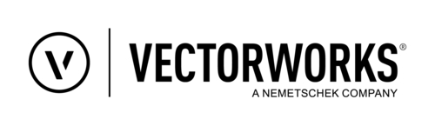
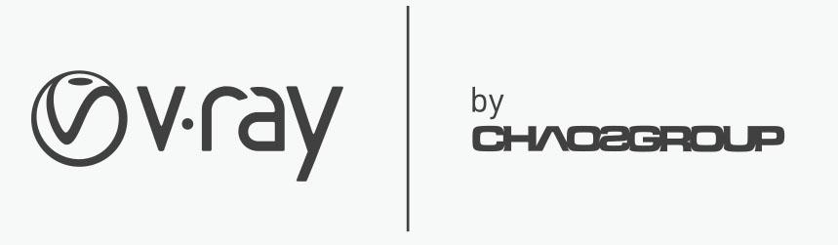 | 
 | 
 | 
 | 

